**Simple approval Workflow**

Flow the Steps below: -

1. Create a SharePoint list “List01”
2. Create new Automated workflow
3. Search SharePoint and select When an item is created trigger
4. Enter Site address and List Name

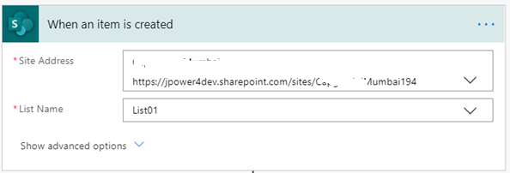

1. Add an action Start and wait for an approval
   1. It will wait for an approver to complete his action.
2. Select Approval type
3. Enter Title
4. Enter assigned to group/user
5. Fill all columns

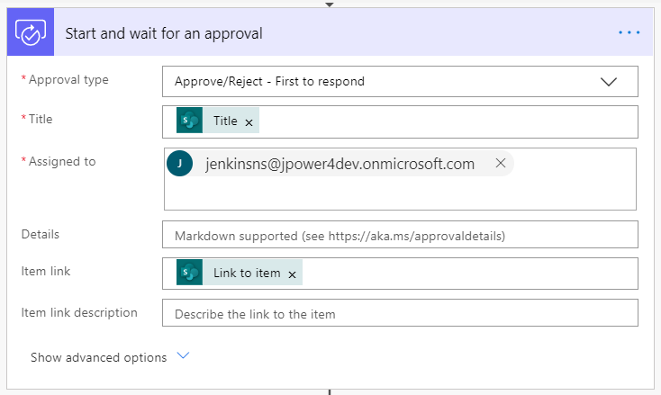

1. Add a new action
2. Send an email notification
3. Fill to, Subject and body with outcome from workflow.

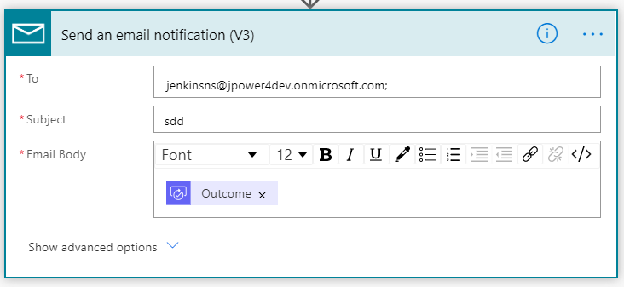

1. Save and test the workflow
2. Add new item in SharePoint list
3. Then go to flow.microsoft.com 🡪 Action Items🡪Approvals
   1. Approve or reject the item

**Approval with Condition flow**

Flow the Steps below: -

1. Create a SharePoint list “List01”
2. Create new Automated workflow
3. Search SharePoint and select When an item is created trigger
4. Enter Site address and List Name
5. Then add Start an approval action

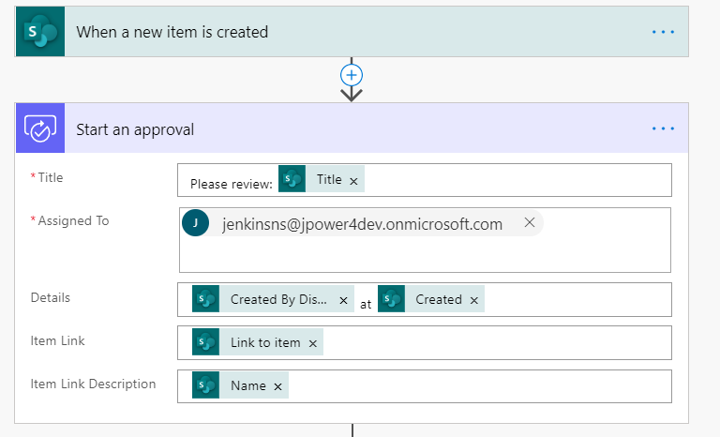

1. Fill title, assigned to, details and etc…
2. Add an action condition (if yes/No)
3. Check approval response is equal to Approve
   1. If yes – do the action
   2. If No – do another action
   3. Here for our lab section added email to creator

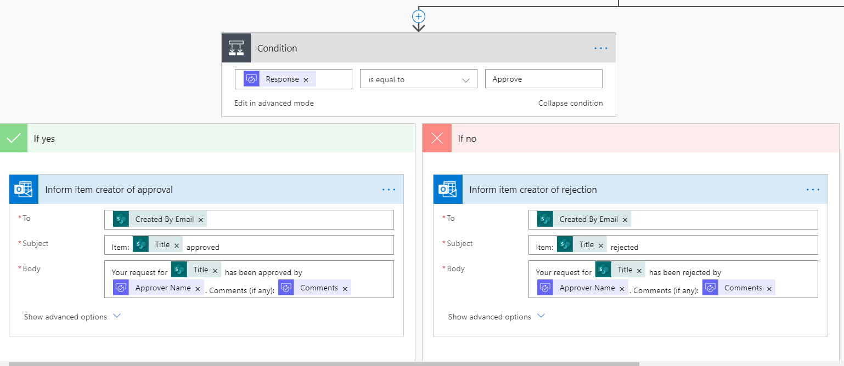

1. Save and test the workflow
2. Add new item in SharePoint list
3. The go to flow.microsoft.com
4. Action items🡪 approvals
   1. Approve or reject the item.